Software Engineering and Testing

2014

Analysis and Design

Institute of Technology Blanchardstown



Under Supervision

Simon McLoughlin Lecturer IT Blanchardstown

Group Members

B00058026 – Nicky Randles

Email: [B00058026@student.itb.ie](mailto:B00058026@student.itb.ie)

B00053401 – Anthony Manson

Email: [B00053401@student.itb.ie](mailto:B00053401@student.itb.ie)

**Project Description**

The aim of this project is to develop an online cinema ticketing office. Through an online webpage the system will allow customers to buy cinema tickets and items 24/7. It wll be simple and easy for the user to use. Once the use makes a purchase they will receive an invoice which they can print off.

**UML Use Case Diagram**

A use case diagram is used to show the interaction between different users of a system and the system. The use case diagram we have created show the relationship the customer, credit card company, sales person and maintainer have with each other and with the system.

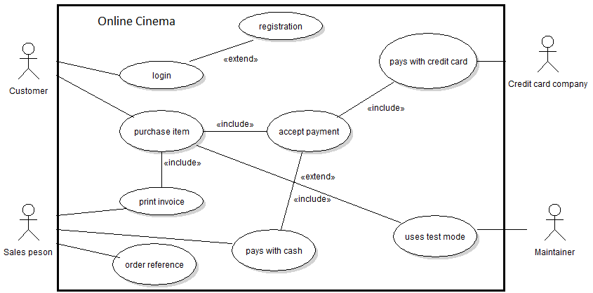

**Use Case Specifications**

Name: login

* The customer must register to use the system.
* The customer must fill in the registration form.
* Customer data is checked.
* The customer’s information is saved in the database.
* Confirmation of registration is displayed to customer.

Name: Purchase item

* The customer looks through the list of films and items.
* The customer can update their shopping basket.
* The customer must confirm the shopping basket.
* System calculates the total amount.
* The total amount is displayed to customer.
* Customer selects payment option.
* System verifies payment.
* Order confirmation is displayed to customer.

Name: Pays with credit card

* Credit Card Company receives card data.
* Credit Card Company validates card.
* Credit Card Company sends card status to the system

Name: Uses test mode

* Maintainer enters test mode
* Maintainer updates system.

Name: Print invoice

* Sales person checks order reference.
* Sales person prints invoice.
* Sale person issues invoice to customer.

Name: Order reference

* Sales person checks order reference
* Sales persons give customer tickets and items.

`

**UML Class Diagram**

This class diagram shows the different class involved in our system and the relationships between them.

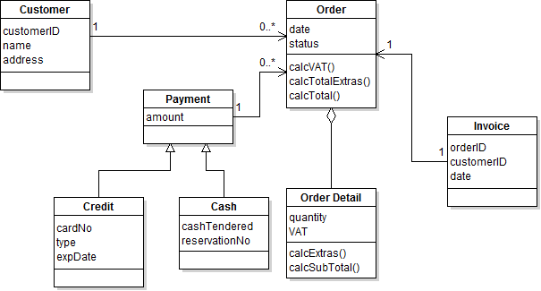

**UML Sequence Diagram**

The following sequence diagrams show how to group of objects in the program work together in the different ways.

Login

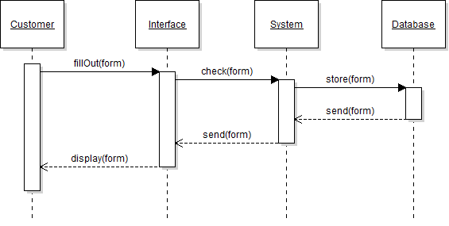

Purchase Item

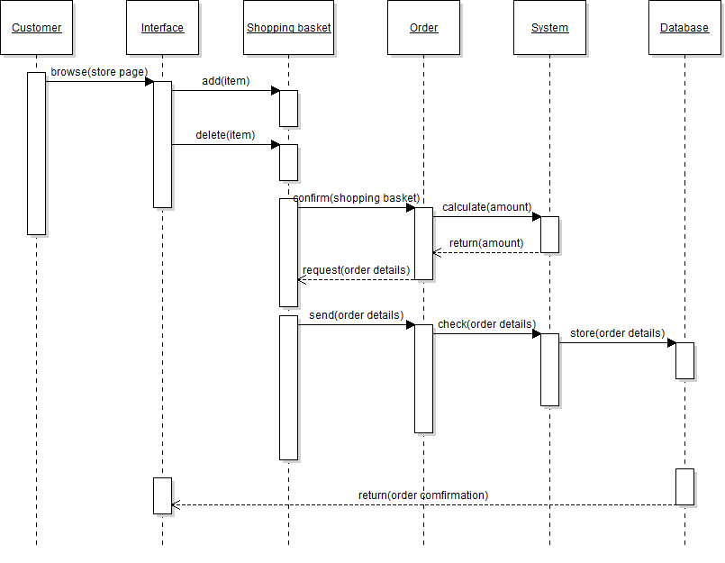

Pays with credit card

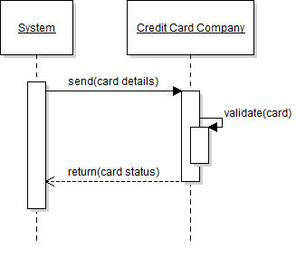

Print invoice

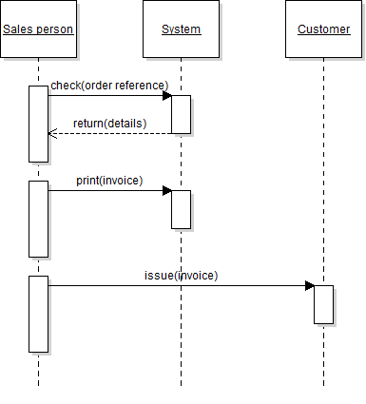

Uses test mode

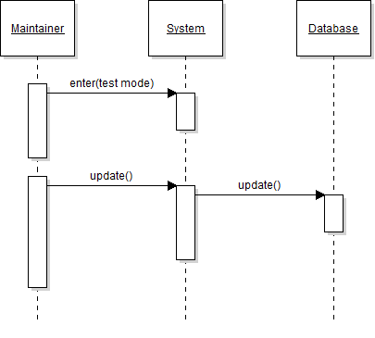

Order reference

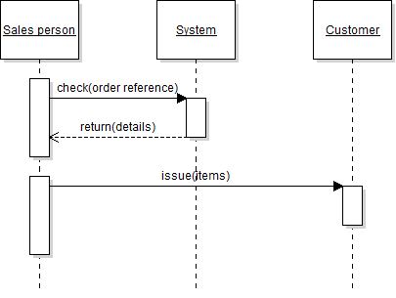

**Use Interface Design**

The user interface is a very important part to the application as this is what the user is going to see. We are going to do are best to make it as user friendly as possible. We will make the pages easier to read by making the text big and dark and the background light to avoid them blending in together. Each page is going to have the same template. This will consist of a header with the stores name and links to the application pages, and the footer will contain information about the different ways to contact the store. The centre of each page will be different; the centre will contain information that is only relevant to that page.

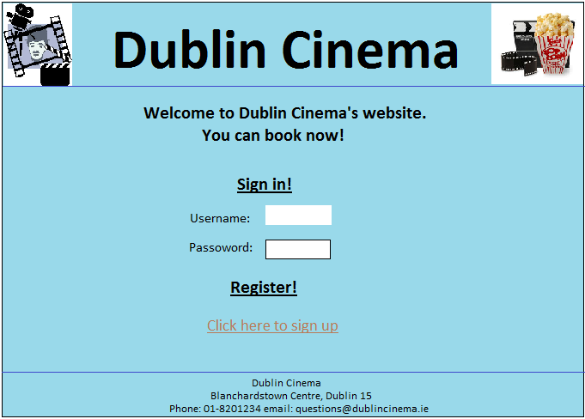

**Database**

